

**Directions to: TD Bank**

**TD Bank**

**Tysons International Plaza**

**2nd Floor**

**1919 Gallows Road**

**Vienna, VA 22182**

**General Location:**

The Metro Washington DC regional headquarters for TD Bank is located within Tysons International Plaza. The primary entrance to the building faces Boone Blvd which is one block off of VA-7 / Leesburg Pike. TD Bank signage is visible on the corner of Gallows Road and Boone Blvd on the building itself.

**Driving Directions:**

* From the 495 Capitol Beltway:
* Take Exit 47A – VA-7 W / Leesburg Pike exit
* Turn left on Gallows Road (CVS on corner)
* Turn left on Boone Blvd (building is on the right)
  + From Leesburg Pike – VA-Route 7 (from the West):
* Turn right on Gallows Road (CVS on corner)
* Turn left on Boone Blvd (building is on the right)
  + From Leesburg Pike – VA-Route 7 (from the East):
* Turn left on Gallows Road (CVS on corner)
* Turn left on Boone Blvd (building is on the right)

**Parking:**

Visitor parking is available at the surface lot in front of the building on Boone Blvd. If you park there, please see the TD receptionist for a parking voucher before leaving. If the surface lot is full, you may park in the below ground lot accessible from Boone Blvd but you will be responsible for parking fees.

**Once Inside:**

* Take the elevator to the 2nd floor
* Once you’ve exited the elevator, walk towards the TD sign and check in with the receptionist

**Map of Location:**

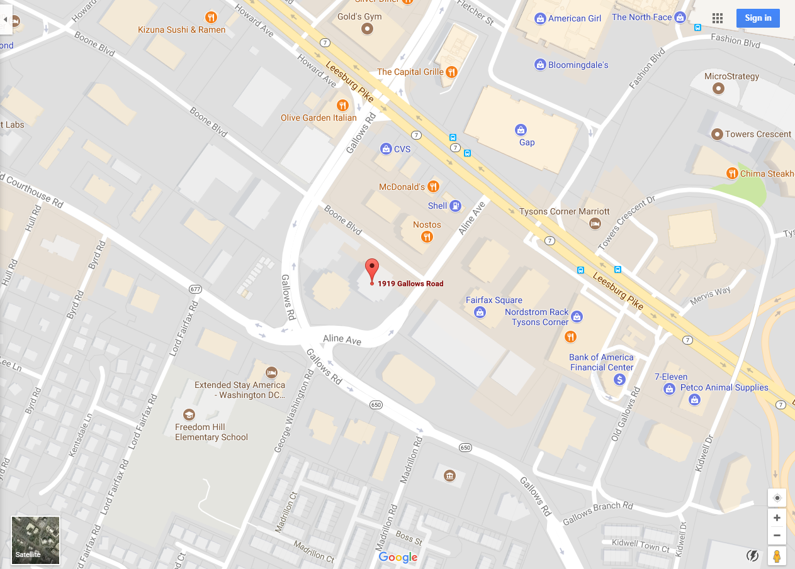

**Picture of Tysons International Plaza (1919 on Left):**

